Python Installation and TMS preprocessing pipeline set-up

**Python Installation and Environment Setup** **3**

Python Installation 3

Environment Setup 3

**Preprocessing Pipeline** **5**

# Python Installation and Environment Setup

## Python Installation

1. Install anaconda:
   1. Go to the following link and download anaconda: <https://www.anaconda.com/products/individual#windows>
2. Double click the installer to launch.
   1. Follow the installation steps, accepting all defaults

## Environment Setup

1. Copy the path to the environment file
   1. Right click the file and click “copy as path”:  
      Example: "C:\Users\Admin\Downloads\TMS_preprocessing_env.yml"
2. Go to search bar and type: anaconda prompt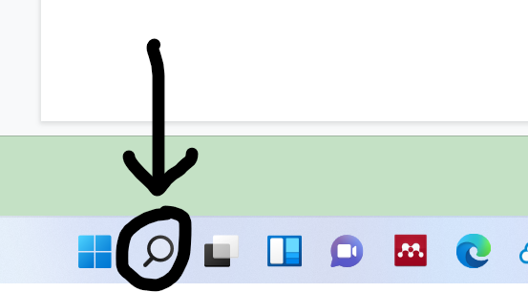
3. Open Anaconda Prompt
4. Type conda env create -f followed by the environment path (environmente path must not have spaces):  
   Example: conda env create -f C:\Users\Admin\Downloads\TMS_preprocessing_env.yml  
   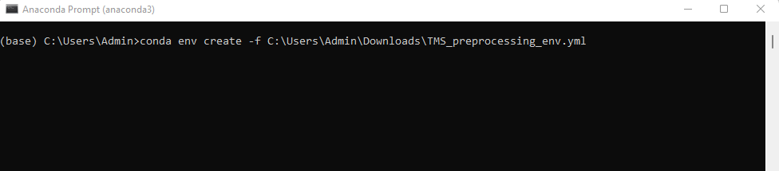  
   (this step may take a few minutes)  
   When finished installing, Anaconda prompt will look like this:  
   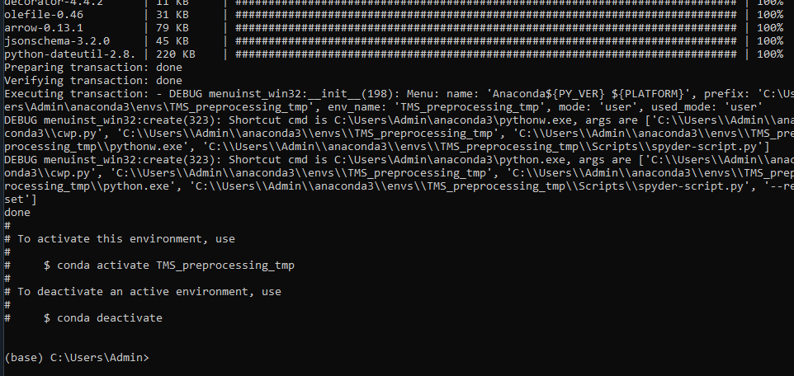
5. Close Anaconda Prompt

Environment Set-up finished

# Preprocessing Pipeline

## Prepare SpyderIDE

1. Go to search bar and type: anaconda navigator
2. Open Anaconda Navigator
3. Select TMS preprocessing from the dropdown menu:  
   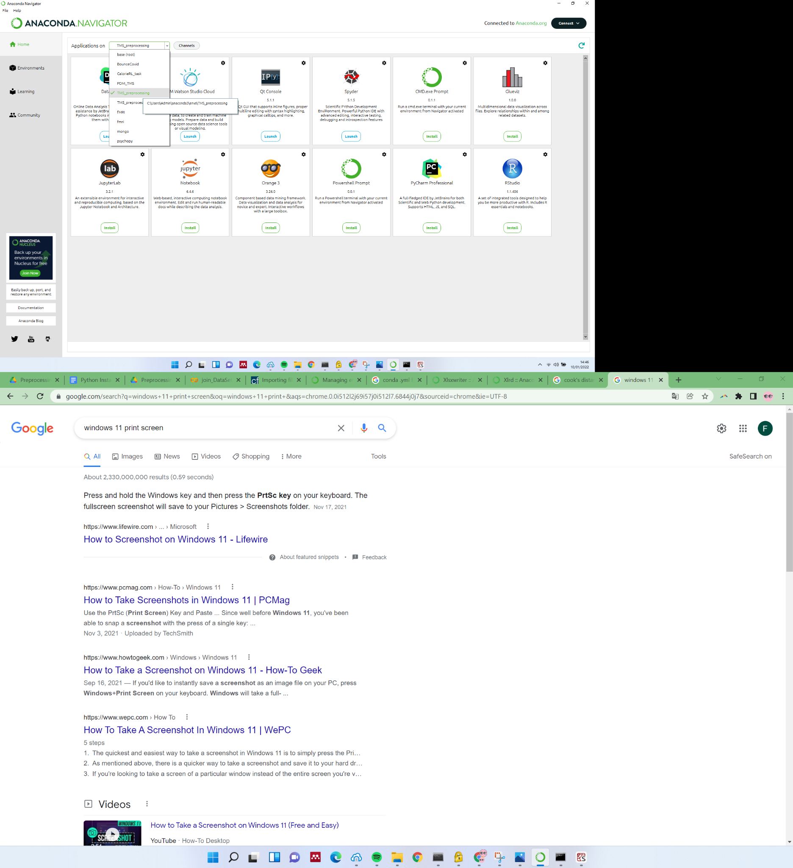
4. Launch Spyder:  
   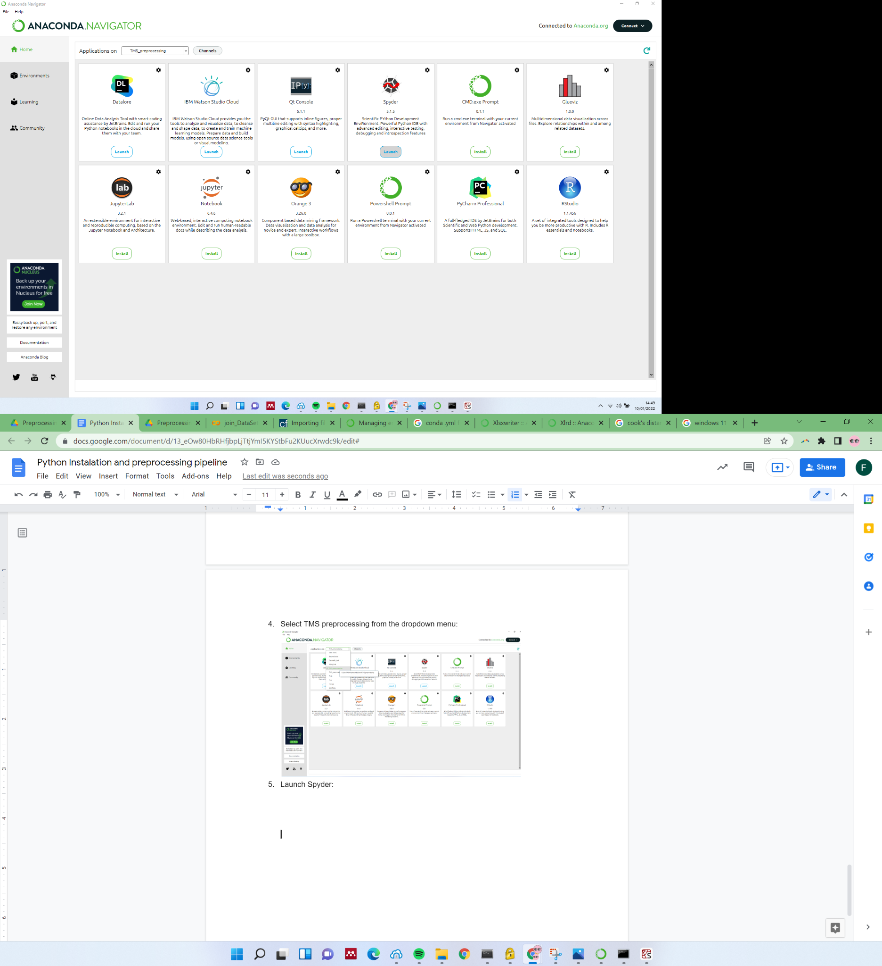
5. Projects > New Project and select folder where you saved the scripts:
   1. 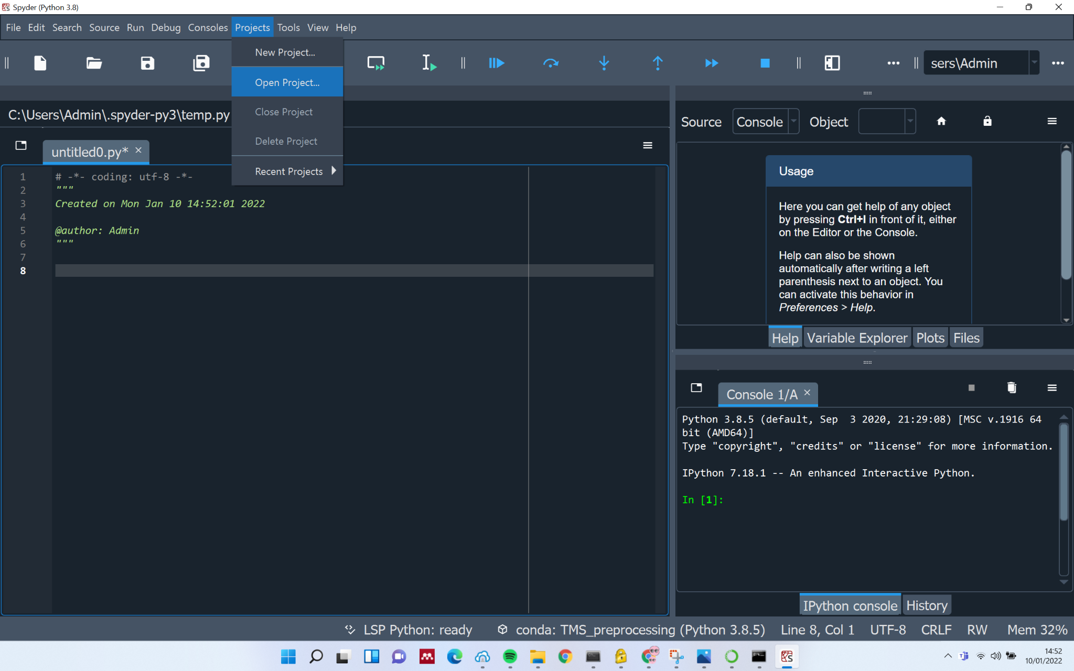
   2. Select “Existing Directory”, navigate to the folder where you saved the scripts and click create:  
        
        
        
        
        
        
        
      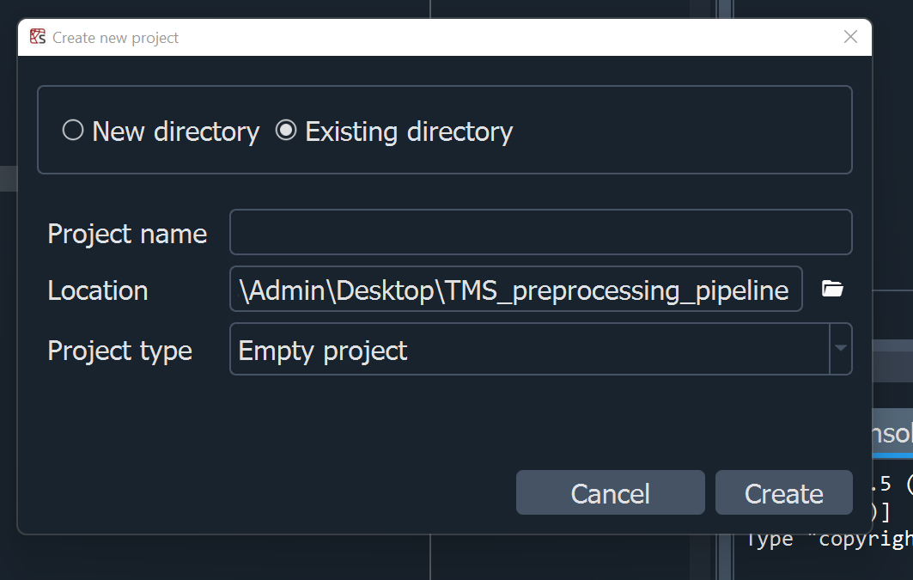
6. 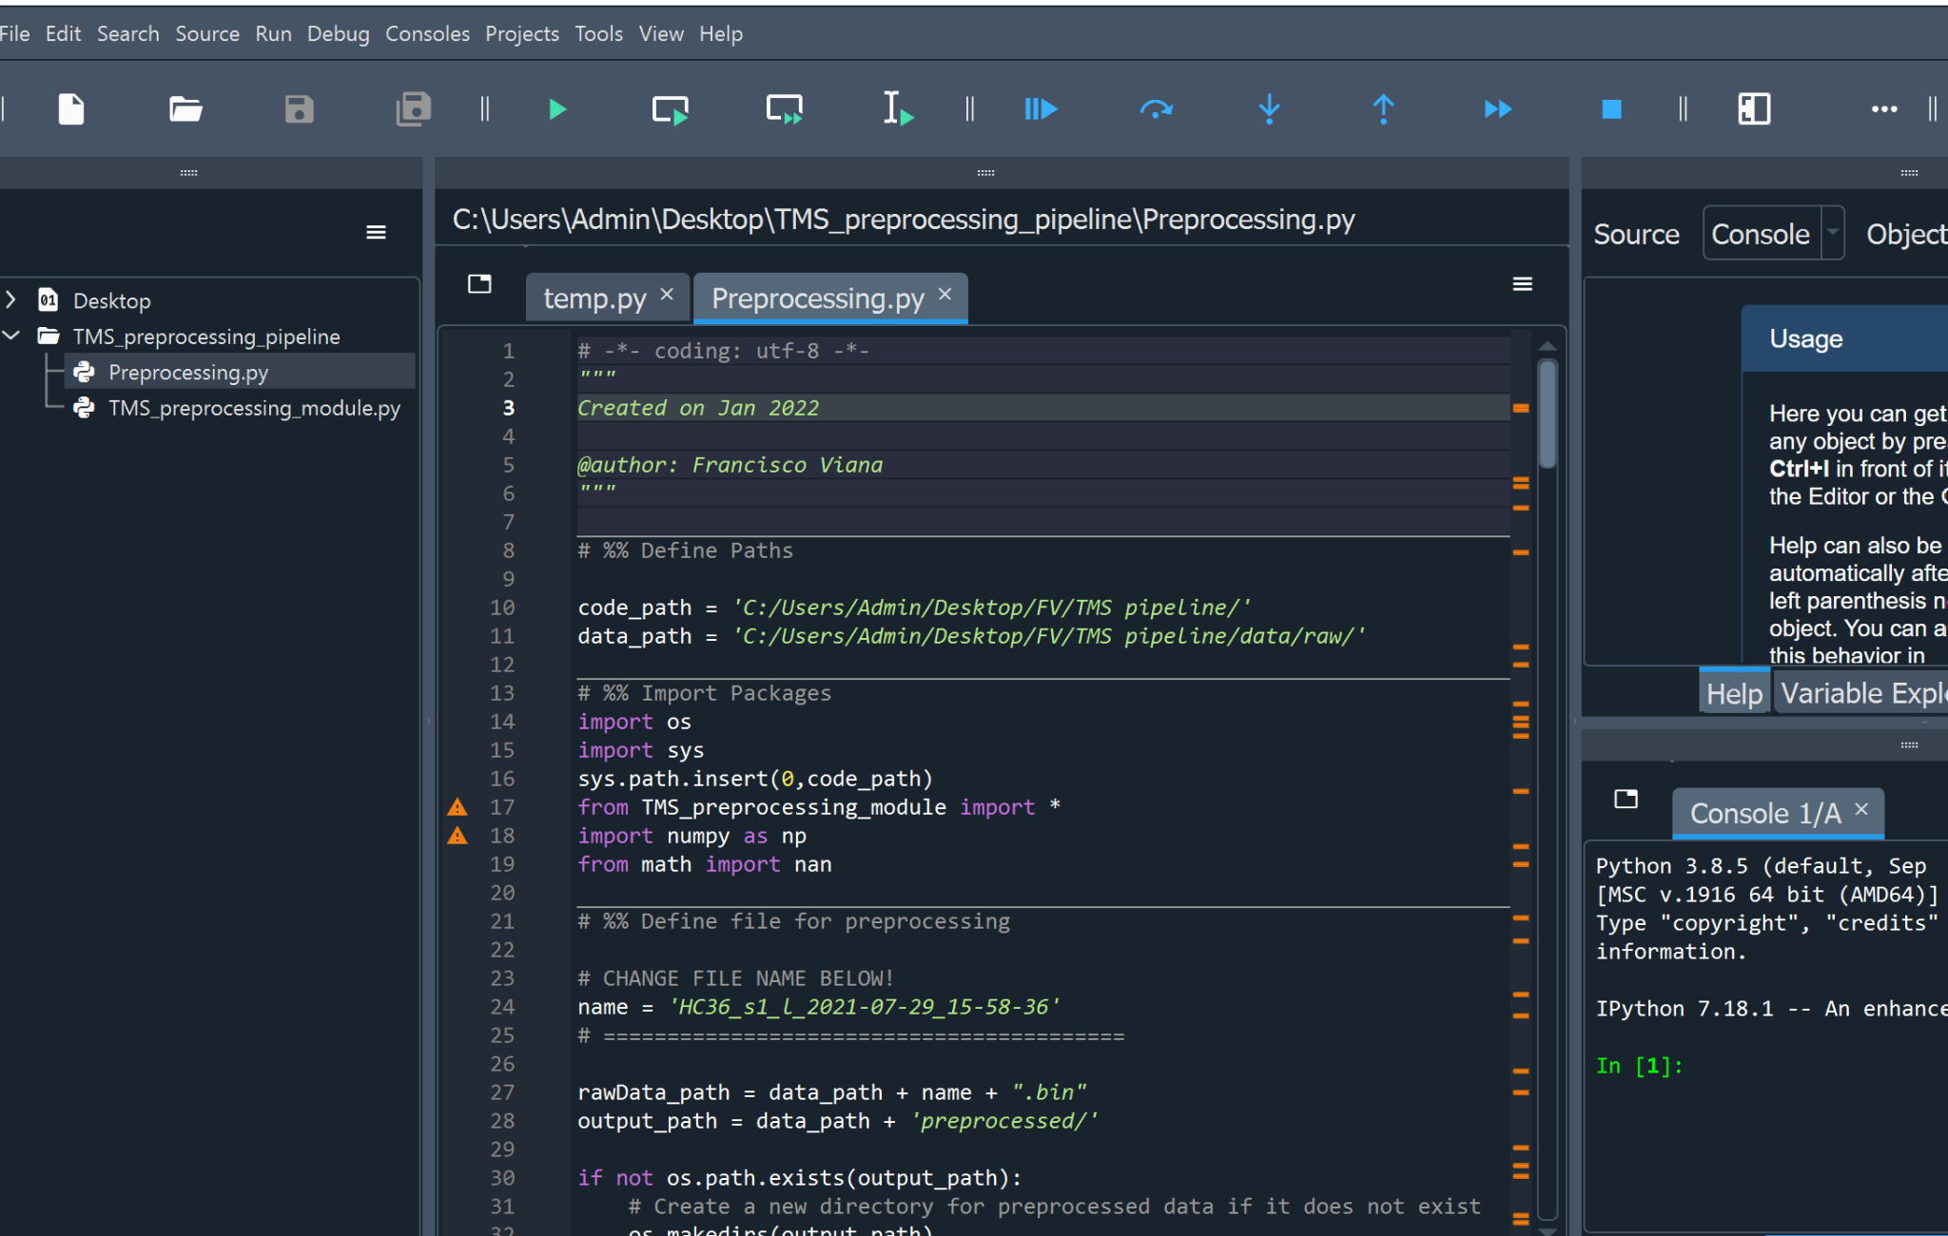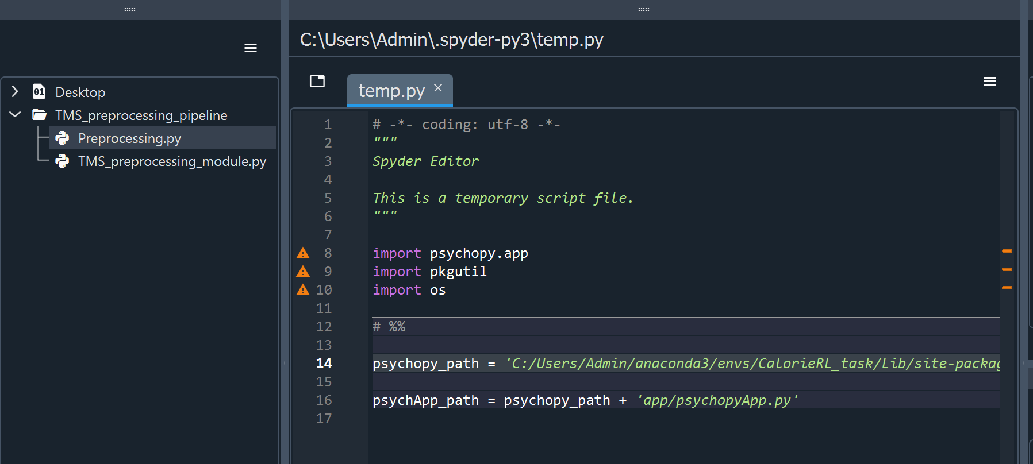A side bar will be opened. Double click ‘Preprocessing.py
7. 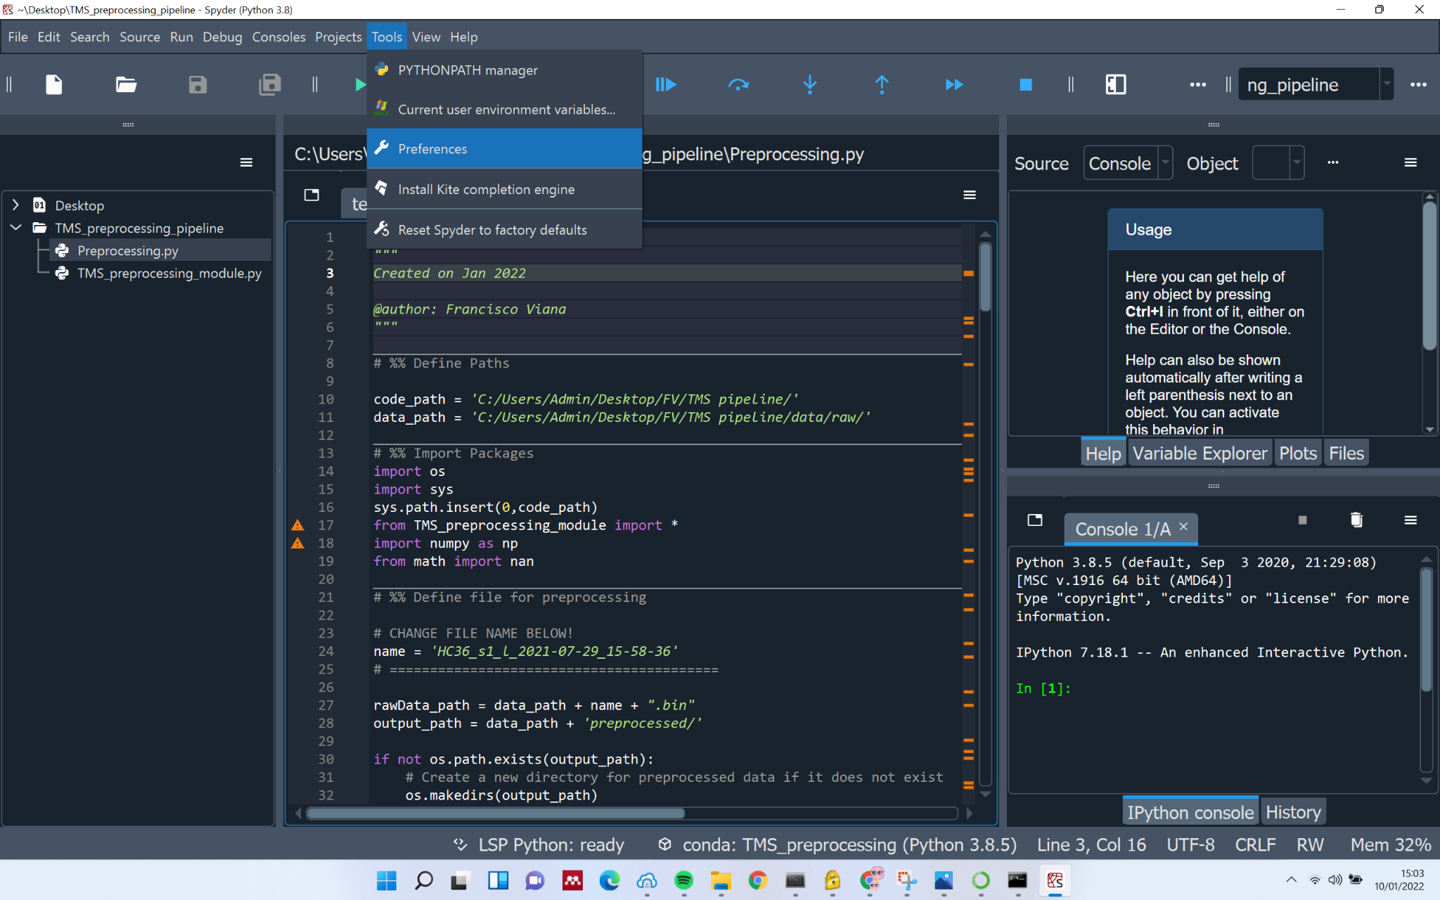Go to Tools > Preferences
8. Go to IPython console > Graphics and select Backend: Automatic
9. Click Apply, then OK and you are ready to preprocess the data!